Assignment 2
Objective-C Types, Protocols, Messaging, Memory

Due Week 5
Chao Zhao 6555985

Task 1 - Class Warfare


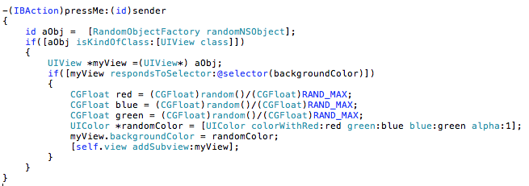
Task 2 - Sticking to Protocol
See Appendices

For the Contact class, it may have different type of contact. They are person or organization etc. These two different instances can present different behaviour. For a person item, it has Date of Birth, home address or office address. However an organization does not have a date of birth. It only has main address or branch address. Without a protocol design, the contact items should design fully functions for each contact item. This design increases the component coupling. Good software should be weak coupling and strong cohesion. The benefits of delegation are making software easy to test and modify.

With the delegation, each instance can execute different behaviours without check instance types.

Task 3 - Memory Management

Manual memory is important in a limited memory space on mobile device. Unlike GC, it saves most memory for users. Users can operate a high performance mobile device.

The Objective C is managed by manually in version 1. In version 2, new memory management is introduced. Keyword Autorelease is used to dealloc the unused variable. The advantage is can reduce the developer’s work. However the problem is system may not release the unused variable immediately. If the system is busy to process data, it will release the memory when system is idle.

Also, if the memory is allocated by alloc and init, it must be released, when it is not useable. When an instance’s method release is called, memory will be free immediately.


source: http://imamraza.files.wordpress.com/2010/02/autorelease.png

Objective C memory management rules are reference count. When an instance is created, the count number increased to 1. The reference count is increased (it’s 2), when is address is copied. When the release method is called, reference is decreased. Deallocate method is called when the reference count is 0;

In the Objective C, each variable is treated as a pointer. When declare a variable, the asterisk (*) is inserted before variable name. Keyword id is a data type for all variables. Asterisk is not need to insert to declaration statement.

Retain, The original variable reference count is increase by 1. Keyword copy is copy the content of variable. The original variable reference is not changed.

